**CUSTOMER CARE REGISTRY**



**PERFORMANCE TESTING**

**TEAM DETAILS:**



**Team No College Name Department**

**:** PNT2022TMID26814

**:** DHANALAKSHMI COLLEGE OF ENGG AND TECH

**:** Computer Science & Engineering

|  |  |
| --- | --- |
| Date | 03 –NOV -2022 |
| Team ID | PNT2022TMID26814 |
| Project Name | Customer Care Registry |
| Maximum Marks | 10 Marks |

TEST PAGE : http://169.51.204.215:31967/

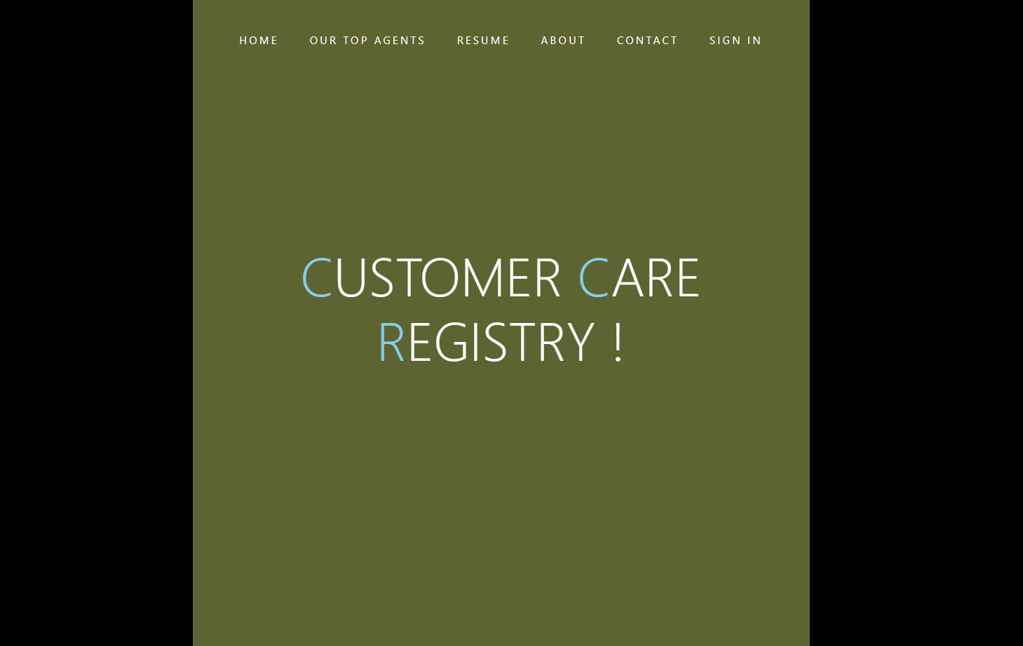

USER LOGIN PAGE :

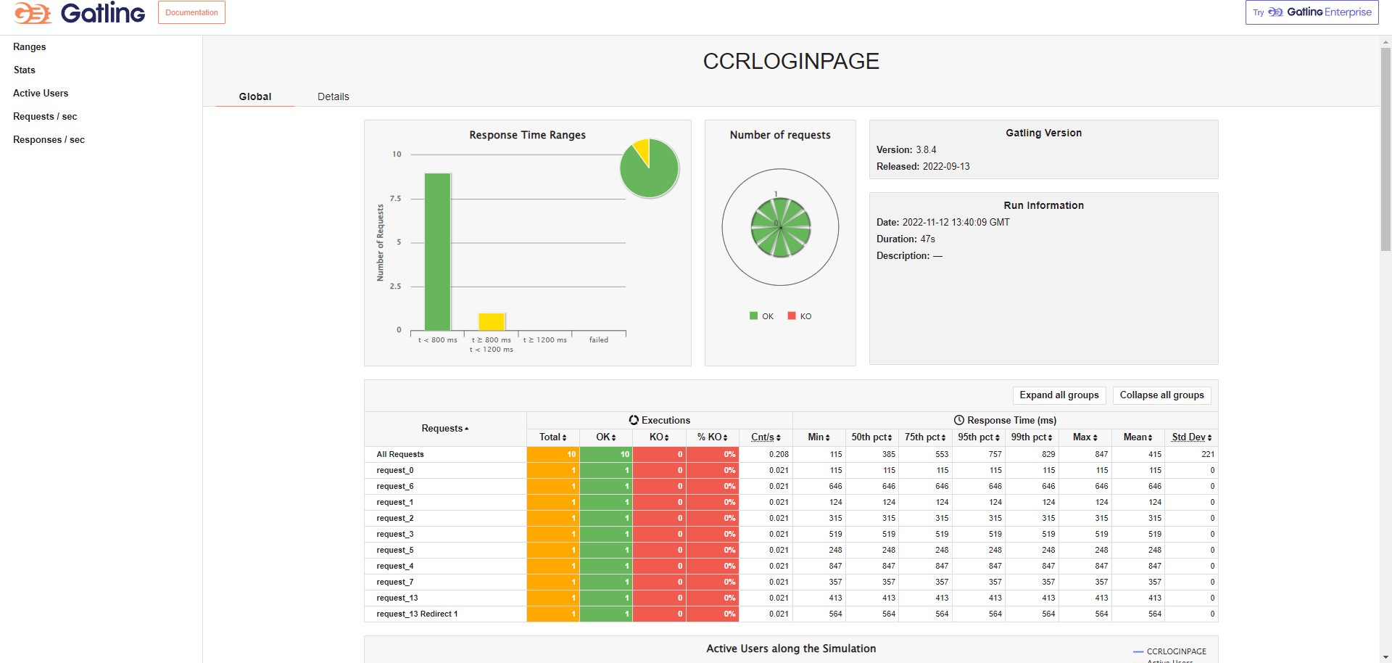

AGENT LOGIN PAGE :

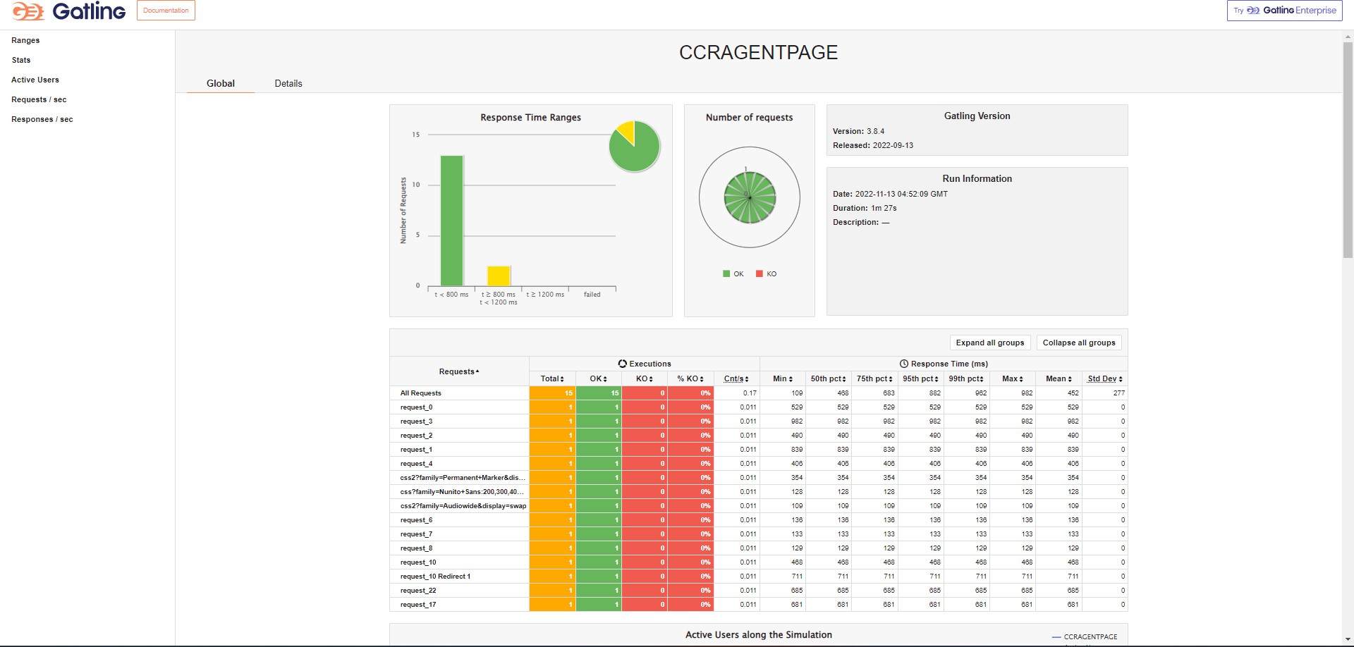

ADMIN LOGIN PAGE :

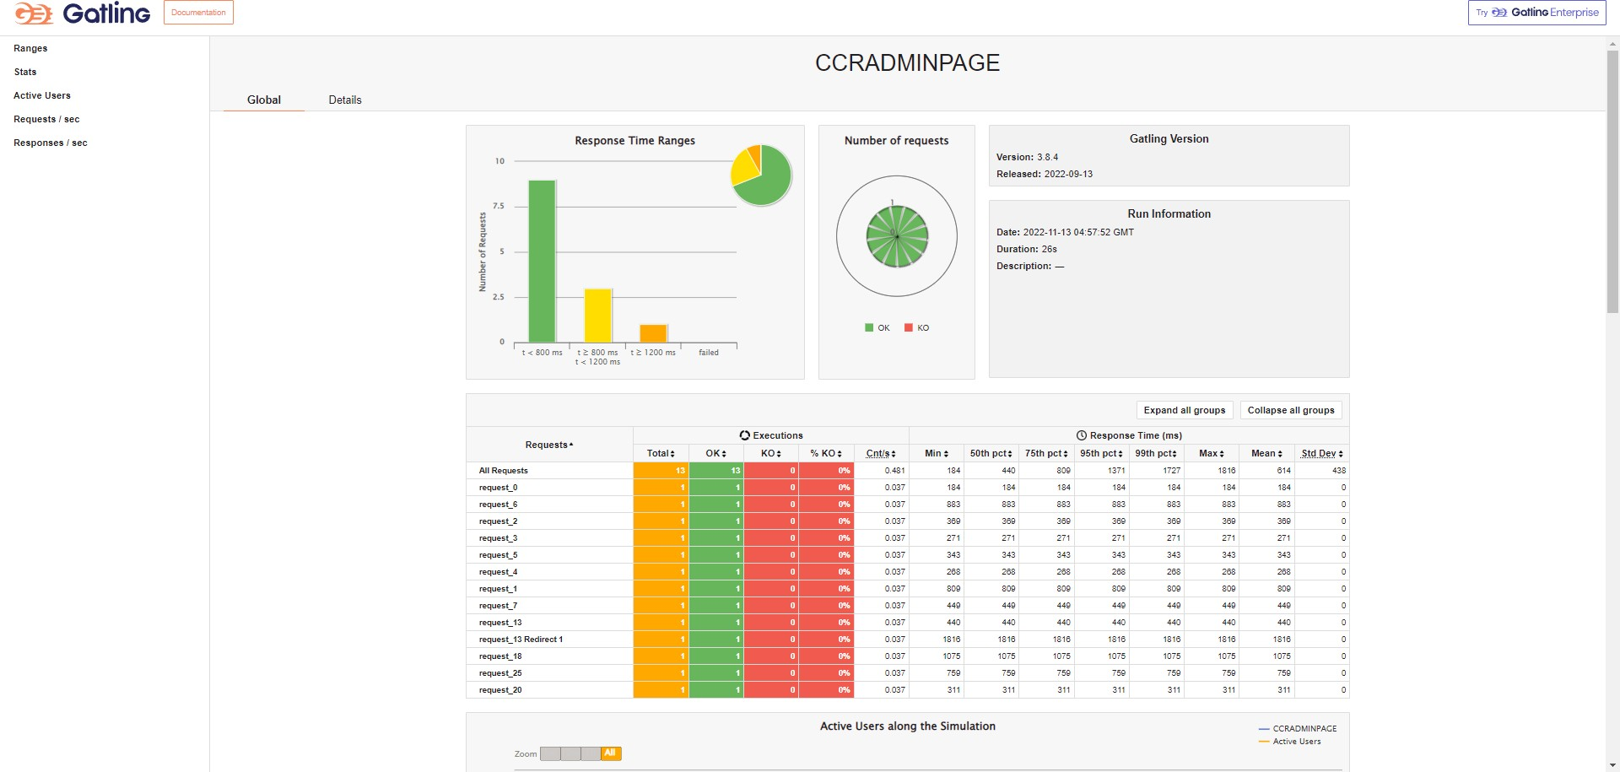

USER COMPLAINT PAGE :

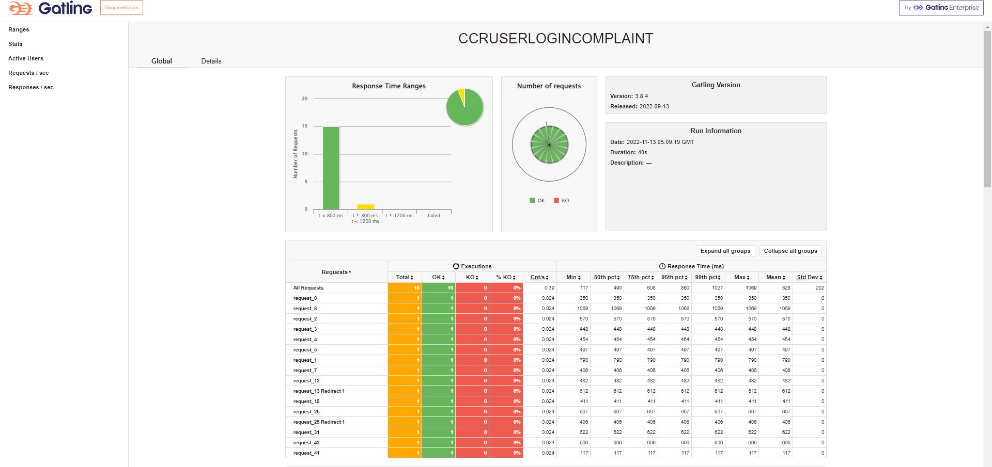

USER ALLOT PAGE :

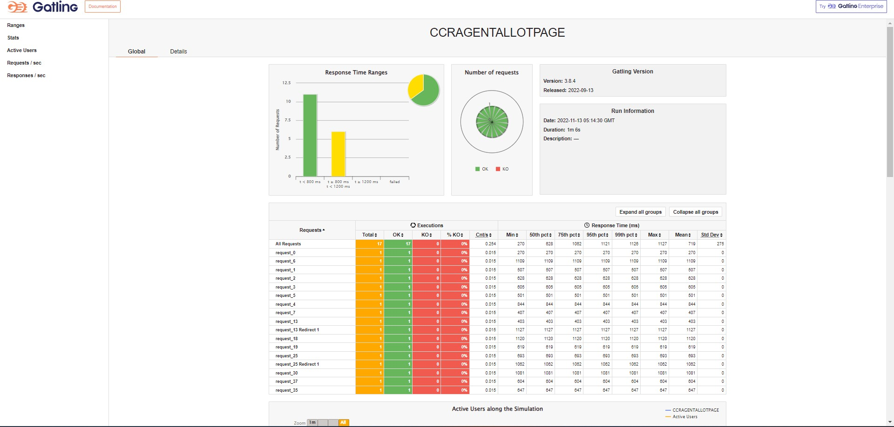



**Thank you**